**Navigating the Future:**

**Assessing the Danger of Industrial Robot Substitution in Your State and Occupation**

Group: CyberPynk

Members: Zhiwen Zhu, Michelle Wang, Heng Jiang, Sami Ouyang

**1. Basic Concept & Overall Objectives**

Our objective is to evaluate the user’s probability of being replaced by robots from both a state and occupational perspective, and then visualize our insights.

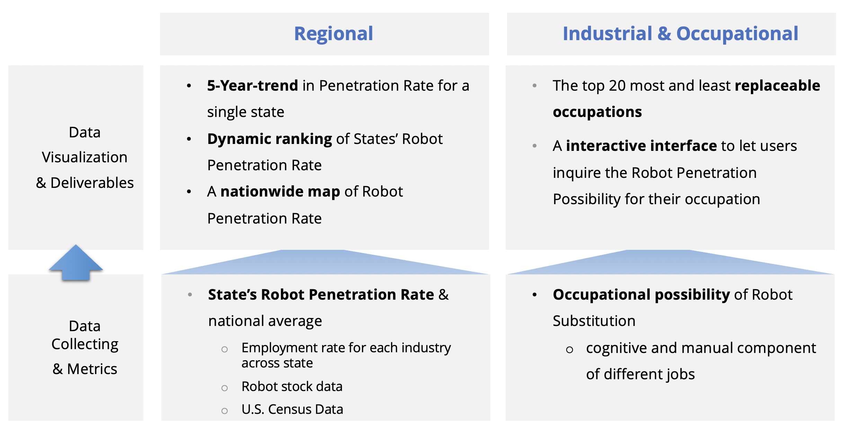

First, **on a regional level**, we will prompt the user for their state of residence and display that state's industrial robot penetration rate. Subsequently, the user will get a comparison of their state robot penetration rate to the national average by charts. The calculation of the penetration rates will be derived from the approach demonstrated by Acemoglu and Restrepo (2020), which will need the US census data, US employment data by industries and states, and the robot stock data from IFR.

We will utilize two Python libraries for creating map-based data visualizations and dynamic ranking visualizations on the data. The users will be displayed a graph featuring the five-year trend in robot penetration in their state versus nationwide. Then, we will generate a **nationwide map** showcasing robot penetration using Pyecharts and a **dynamic ranking** of robot penetration across states, powered by Anicharts.

Second, **on an industry level**, we will prompt the users for their occupations and display the possibility of them being replaced by industrial robots. This possibility will be calculated based on the weight of the cognitive component of that occupation versus that of the manual labor component, considering industrial robots mainly replace physical labor rather than cognitive labor.

Then we can list the **top 20 occupations** that are most likely to be replaced and the top 20 occupations that are least likely to be replaced, along with their replacement scores. The ranking will be visualized using **Matplotlib**. Also, a **user-friendly interface** will be established to allow users to query the occupations level data.

**2. The Basic Use Cases**

1. **Connecting the Future:** Like students selecting college majors based on future outlooks, users can use this application to assess the future career opportunities of their current or prospective occupations based on their likelihood of being automated. This will enable users to make more informed career decisions.
2. **Making Informed Career Moves:** For workers concerned about potential job automation, the geographical data used in this application can be used to gauge the current and projected levels of robot integration across states, which helps them to make better relocation decisions when necessary.
3. **Data-Driven Policy Making:** For policymakers such as those with the US Department of Labor, this application can be utilized to understand trends in robot integration both statewide and nationwide. This insight will facilitate policymaking to regulate robot usage and manage job security.
4. **Unlock Investment Opportunities:** For investors focusing on the robotics industry, this application can be utilized to track the progression of robot adoption across various states. This insight will facilitate their investment decisions.

**3. Tentative Sources of Data and Libraries**

|  |  |  |
| --- | --- | --- |
| **Source** | **Type** | **Description** |
| <https://www.bea.gov/index.php/data/employment> | API | Grab the employment data for each industry in each state for the target year and calculate the robot penetration rates (numerator). |
| <https://www.onetonline.org/find/descriptor/browse/1.A> | Web Scraping | Capture the skill characteristics of different occupations to calculate the danger of robot substitution for that occupation from O*NET. |
| <https://ifr.org/free-downloads/> | CSV | U.S. Industrial Robot Inventory Data by Industry |
| https://data.census.gov/all | CSV | U.S. Census Data for calculate the robot penetration rates (denominator). |
| <https://github.com/pyecharts/pyecharts/blob/master/README.en.md> | Library | Data visualization: Map-based |
| <https://github.com/Jannchie/anichart.js> | Library | Data visualization: dynamic ranking |

**4. Work Plan**

|  |  |
| --- | --- |
| **Team Member** | **Task Division** |
| Zhiwen Zhu 🐰 | · **Calculating** the **State**’s Robot Penetration Rate using a method derived from literature;  · **Vi­­­sualizing** the fluctuation of Robot Penetration Rate over time for a single state with Matplotlib (or Seaborn or Plotly) |
| Michelle Wang 🦊 | · **Retrieving** data from the BEA **API** for the data of urban employment rate by industry across states;  · Creating a **map visualization** of nationwide Robot Penetration Rate using Pyechart |
| Heng Jiang 🐑 | · Developing a method of **calculating** the **occupation**’s possibility of Robot Substitution;  · Visualizing the **dynamic ranking** of States’ Penetration Rate over time with Anichart­­­ |
| Sami Ouyang 🐤 | · Utilizing **web scrapping** to get the skill characteristics of different occupations;  · Establishing an **interactive interface** to let users inquire the danger of robot substitution for their own occupation |